Application of $rename and $unset Keywords Using MongoDB (JDBC)
By Shashank Kumar 24BAI10032

Program:
package crud_operations;

import com.mongodb.client.*;
import com.mongodb.client.model.Filters;
import com.mongodb.client.model.Updates;
import org.bson.Document;
public class Crud_inMongoDB {
public static void main(String[] args) {
// Connect to MongoDB
MongoClient mongoClient = MongoClients.create("mongodb://localhost:27017");
// Access database
MongoDatabase database = mongoClient.getDatabase("CollegeDB");
// Access collection
MongoCollection<Document> collection =
database.getCollection("Students");
// Rename a Field
collection.updateOne(
Filters.eq("id", 100),
new Document("$rename",
new Document("department", "branch"))
);

System.out.println("Field renamed successfully.");
//Unset (Delete a Column/Field)
collection.updateOne(
Filters.eq("id", 102),
new Document("$unset",
new Document("cgpa", ""))
);
System.out.println("Field deleted successfully.");
mongoClient.close();
}

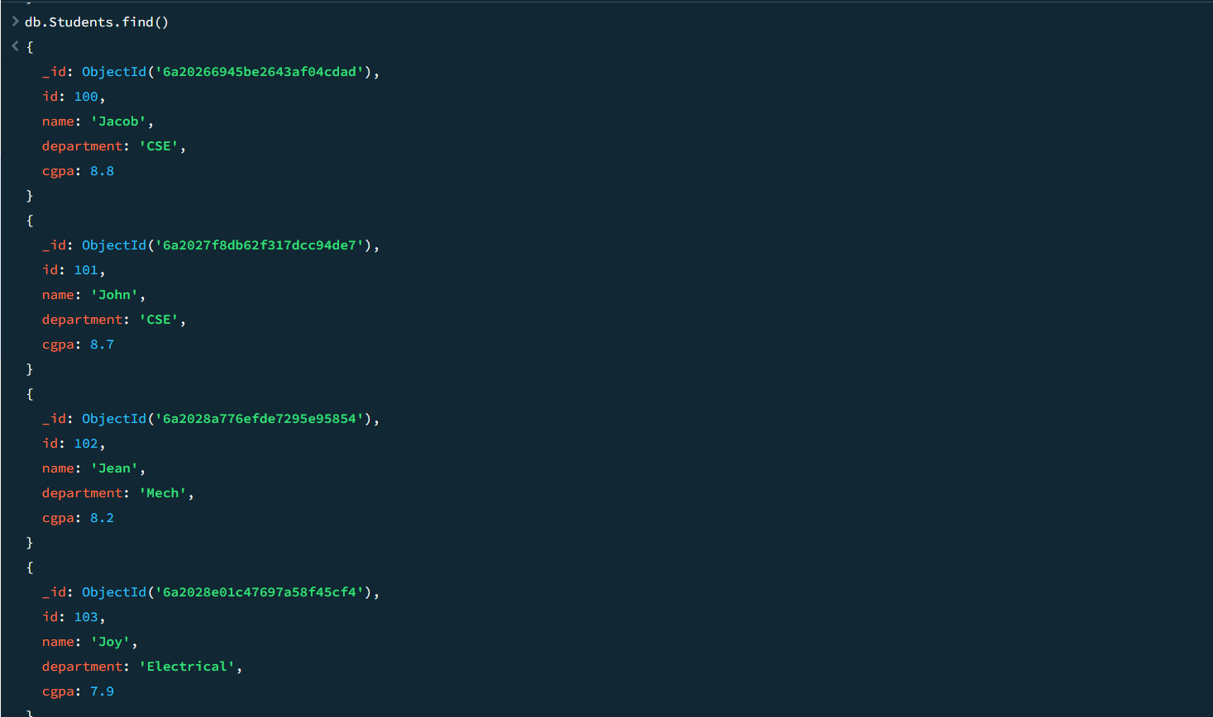
Initial Database:

After Program Execution:
